**Chapter 3 Assignments**

**Chapter Review:**

1. B
2. D
3. B
4. C
5. C
6. D
7. A
8. C
9. C
10. C
11. D
12. D
13. D
14. C
15. D
16. C
17. B
18. C
19. B
20. A

**Chapter Exercises:**

Exercise 1:

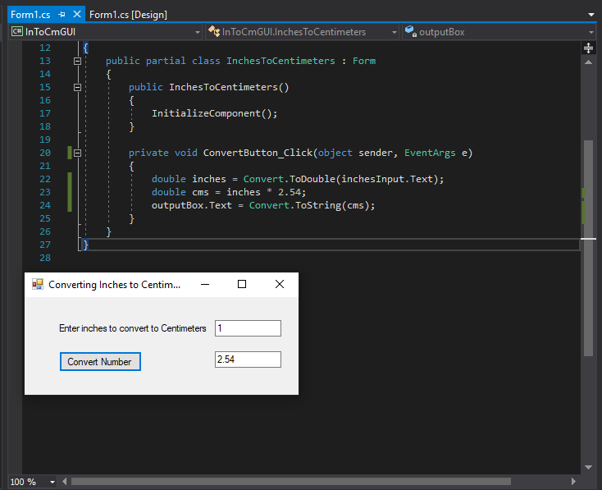

Exercise 3:

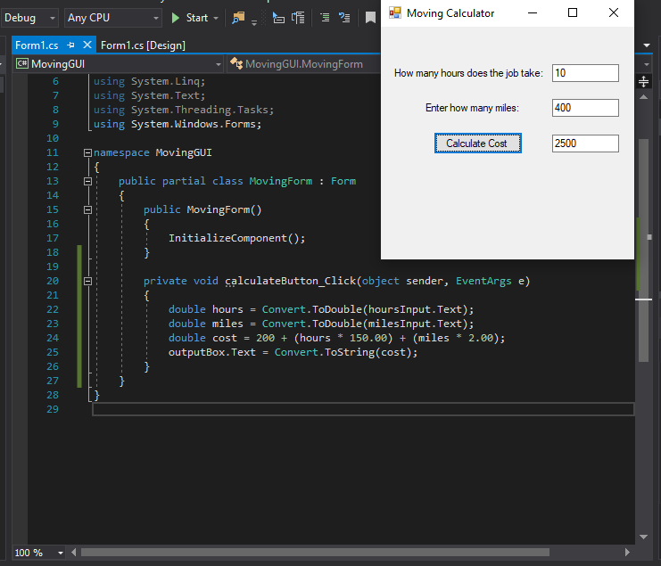

Exercise 5:

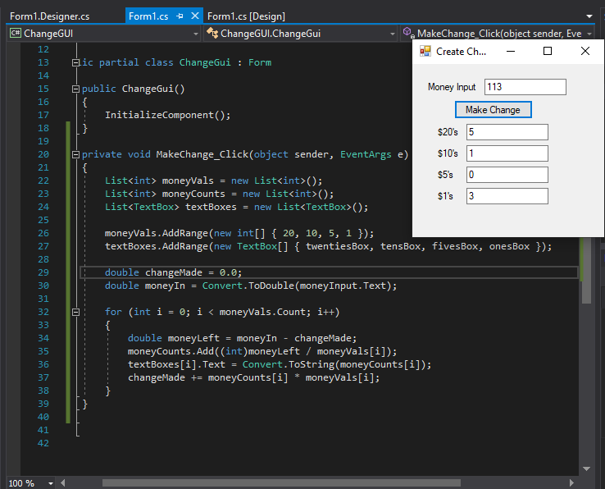

**Debugging Exercises**

Debug 1: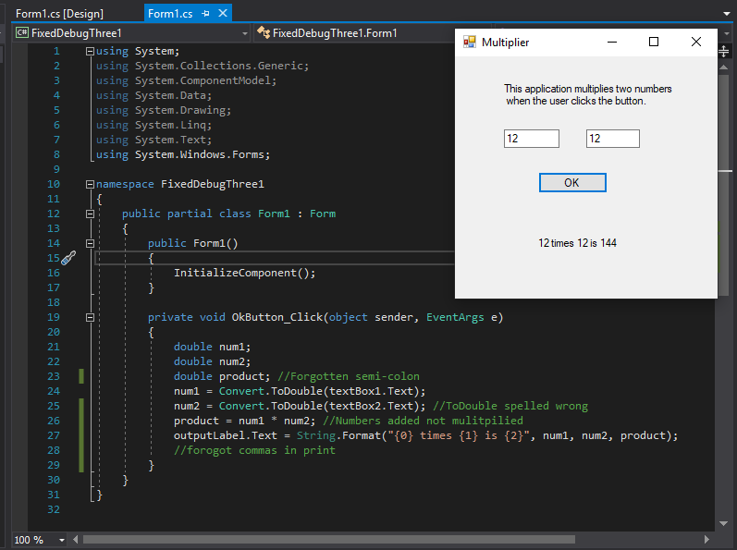

Debug 2: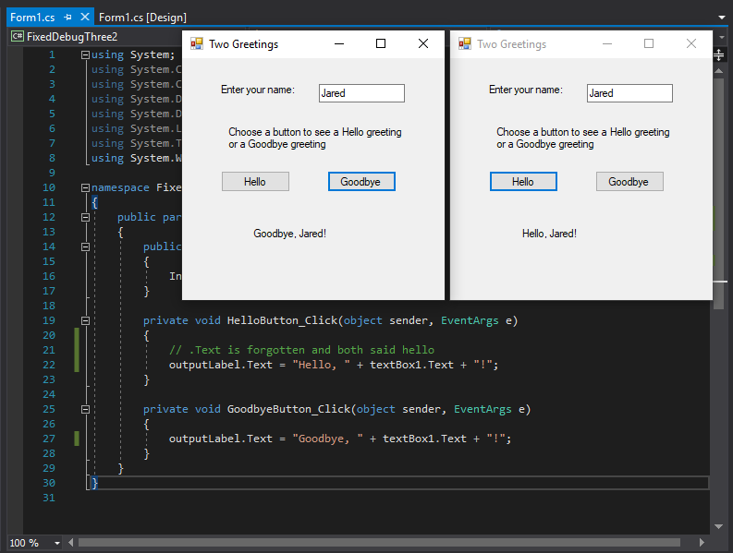

Debug 3: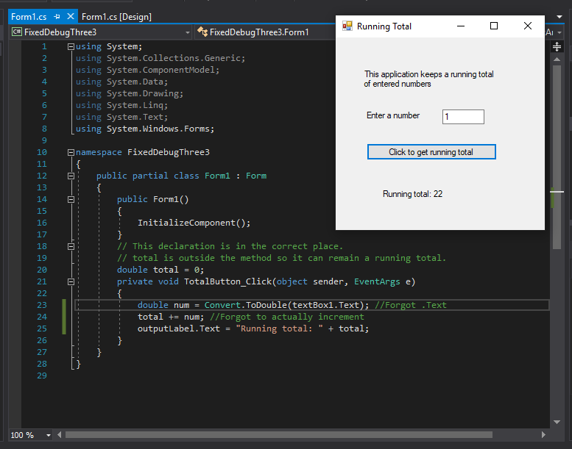

Debug 4: